**How to create remote links:**

There are 2 ways to create remote links that can be accessable by everyone.

If you need to send a link while working remotely, you will need to email the link to yourself and copy and paste the link accordingly in order for the person receiving the link to be able to open it.  It is also recommended that you note the location of the document in the email as well.

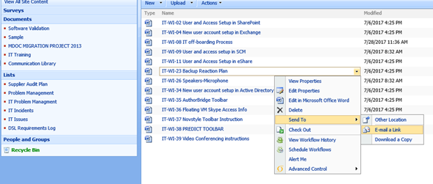

If you need to send a link while working remotely, you will need to modify the link in order for the person receiving the link to be able to open it.  It is also recommended that you note the location of the document in the email as well.  Please see the two links below.  The first link was copied while working remotely and has <https://remote.mmsholdings.com> and ,DanaInfo=.amnuviw1lz4wF+ in the address.  This link will not work.  The second link has replaced <https://remote.mmsholdings.com> with [http://mmsservervm6](http://mmsservervm6/) and removed ,DanaInfo=.amnuviw1lz4wF+ from the link.  The second link works.

<https://remote.mmsholdings.com/Departmental%20Training%20%20Educational%20Information/,DanaInfo=.amnuviw1lz4wF+Signal%20Detection%20Overview.ppt>

<http://mmsservervm6/Departmental%20Training%20%20Educational%20Information/Signal%20Detection%20Overview.ppt>

The best way to modify the link is to right click the link and select “Edit Hyperlink” from the menu.

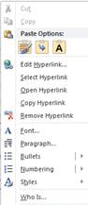

Change the link address on the address line below.

