Batch Upload Instructions

- To do this, you must create a personal view. Within your internal client project page, at the top left corner of MDOC, open the “Library” view and the select “Create View”. This will open a new page. From there, select “Standard View” from the options.
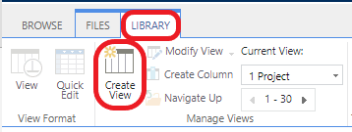
- Name your personal view in the “View Name” box on the right side of the screen.
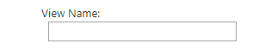
- For documents uploaded the same day, as you scroll down, modify the personal view under the “Filter” header by selecting “created by” and “Modified (Indexed)” as shown in the picture below. Type the appropriate information in the text field box. For items submitted on the same day, enter “[TODAY]” in the bottom box as shown. If the desired range is further back, a number of days can be subtracted from today by typing “-X” after [TODAY]. (Ex: for a range of the last 30 days, enter “[TODAY]-30”)
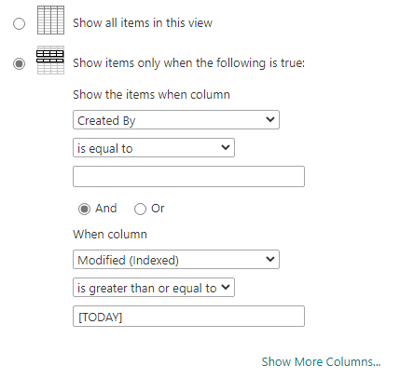
- Continue to scroll down, and expand “Group By” and make sure it is set to “None” as shown below
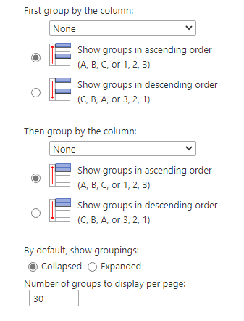
- Click “OK” at the bottom of the list of options:
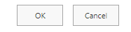
- Your personal view opens.
- You can edit or delete this custom view at any time from the “Library” and “Create View”

More information on this topic can be found on the Microsoft support page:
- https://support.microsoft.com/en-us/office/use-filtering-to-modify-a-sharepoint-view-3d8efc52-0808-4731-8f9b-3dfaeacea3d4
- https://support.microsoft.com/en-us/office/create-change-or-delete-a-view-of-a-list-or-library-27ae65b8-bc5b-4949-b29b-4ee87144a9c9#OfficeVersion=classic

