Step 1: On the Right hand side click on the Circle and go to Account Settings.
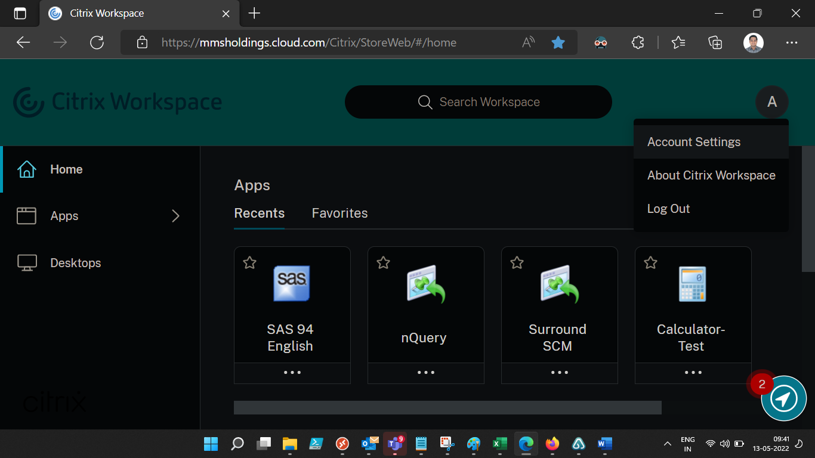
Step 2:
Click on “Advanced”
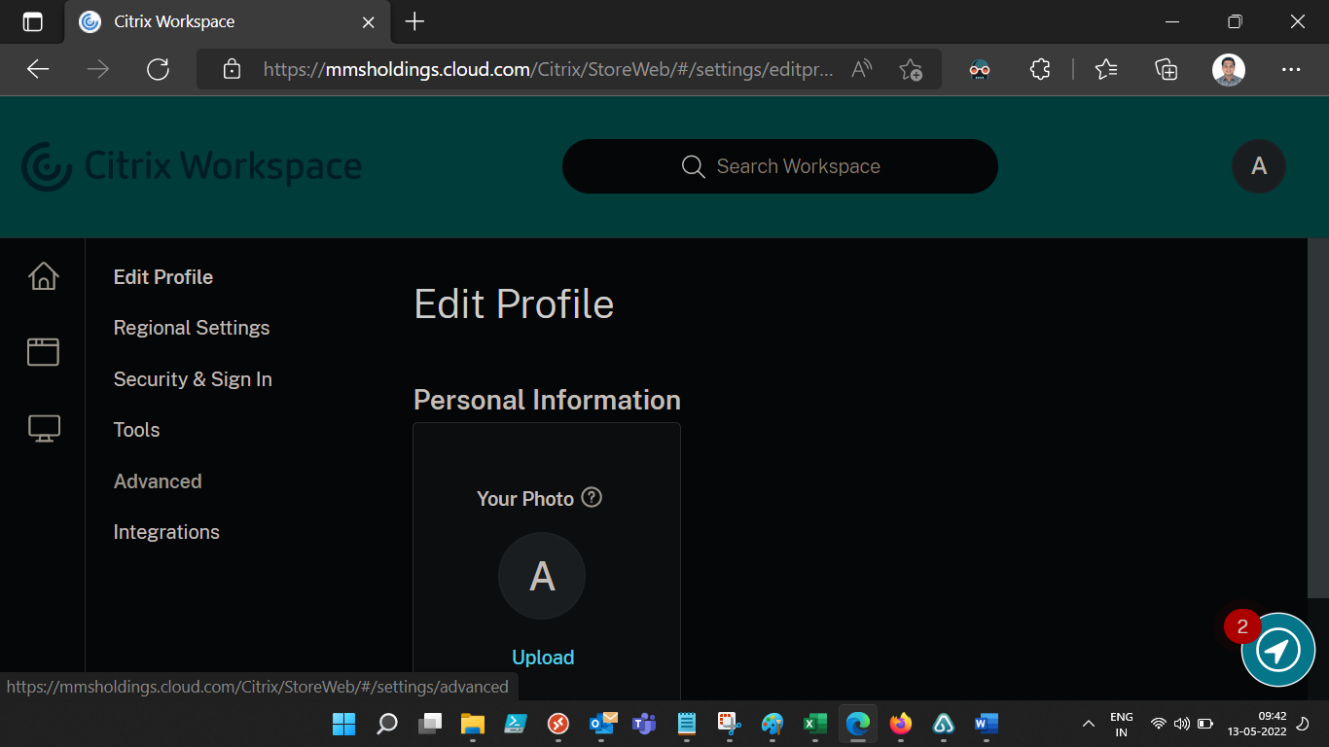

Step 3: Click on Use Web Browser
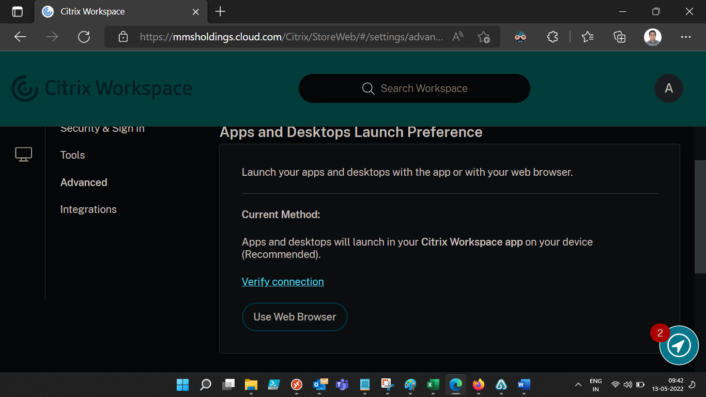
Step 4: Click on Use Web Browser again.
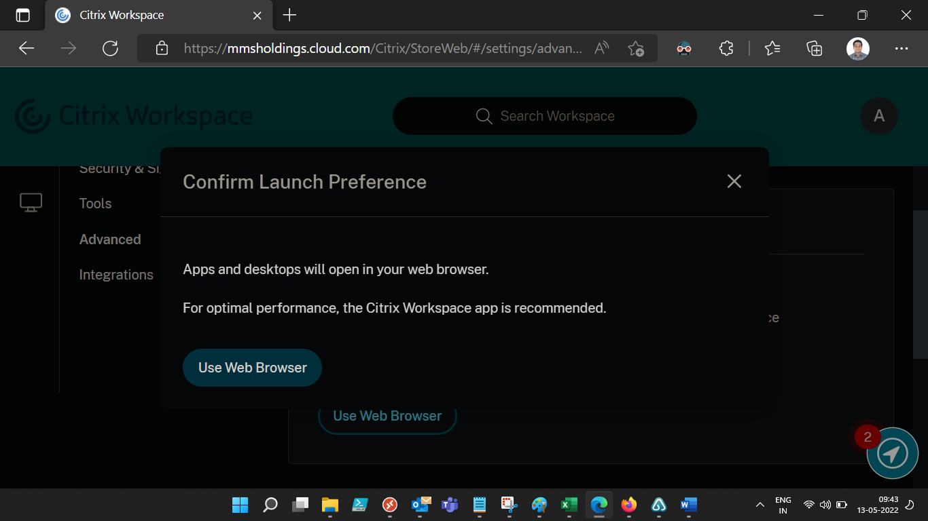

The default app will be your web browser.
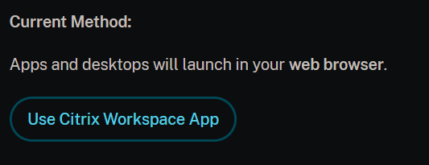
Go Back to Citrix Workspace Home
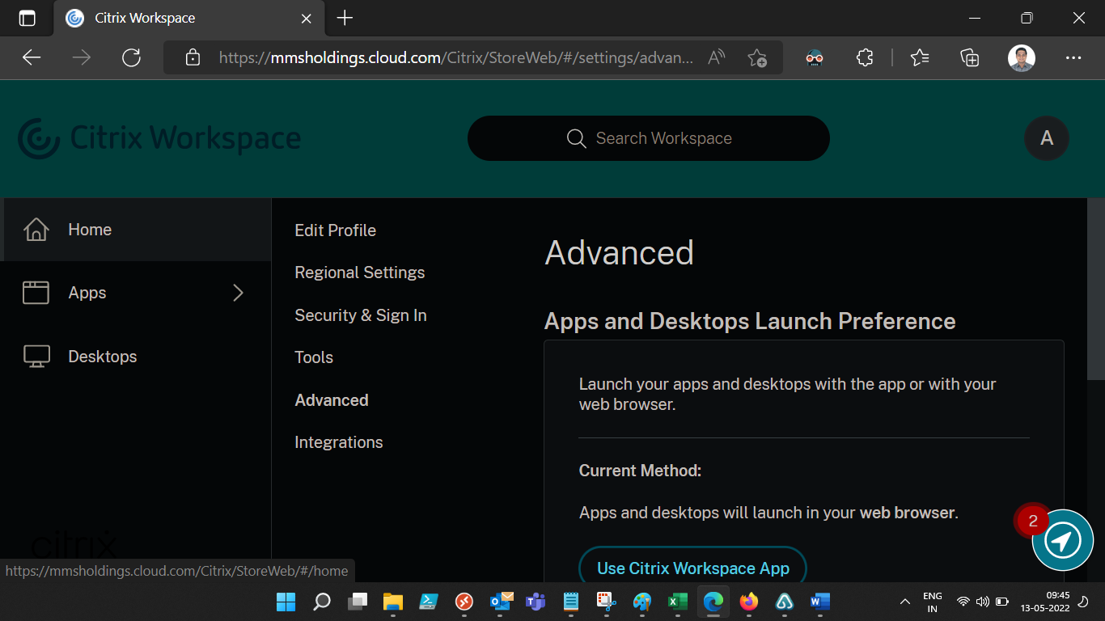
Then launch SAS and SCM one by one and the apps will load in your Web Browser. This is just a workaround and IT will update you once this issue is resolved.

