Instructions for installing extension in Google Chrome

Step1: On the below prompt, please click on Extension as shown below
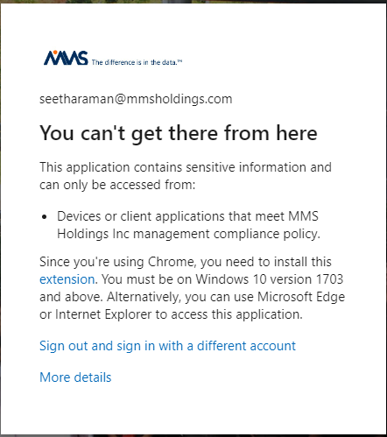

Step 2: On the below prompt, please click on “Add to Chrome” as shown below
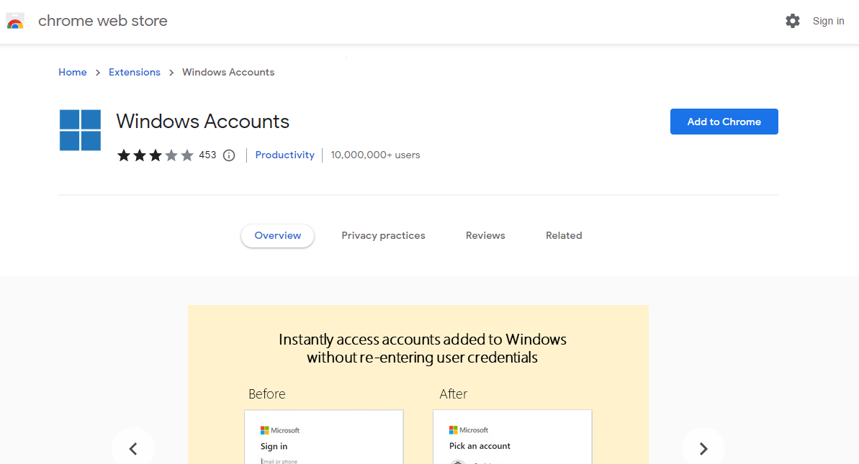

Step3: On the below prompt, please click on “Add extension” and you should be all set.
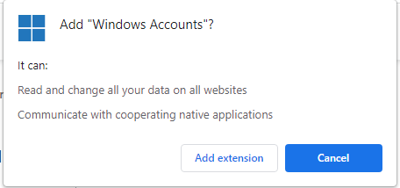

Step4: Close the google chrome browser, re-open again and try to access the link.

